National Search & Recovery Conference open to all SAR teams and members

This year at the Dive Ireland Show, once again CFT will host a National Search & Recovery meeting open to all SAR dive teams operating in Ireland (whether CFT members or not) to gather and listen to speakers from The Coast Guard and Garda Síochána on SAR topics and to meet other teams from across the country. There is a guest speaker this year from Finland showcasing a new navigation and communication system leveraging 3D underwater tracking by satellite GPS.

Did you know that since May 2016 the Clubs in CFT and The Irish Coast Guard have a Service Level Agreement enabling certified Search and Recovery divers to volunteer when "asked to ask" by the IRCG in SAR operations? Chris Reynolds was a speaker at the Dive Ireland Show in 2016 and presented to a packed audience of SAR volunteers from all over Ireland. "We look forward to a progressive working relationship with CFT long into the future. I believe this is a very good day for search and recovery in Ireland and will help bring closure to the loved ones of those that go missing in our waters.” – Chris Reynolds, Director of the Irish Coast Guard.

Image in Dropbox: https://www.dropbox.com/sh/r93r3yfnksgwzfb/AABQvtZkes2pwy9Q8ZqCdcoia?dl=0

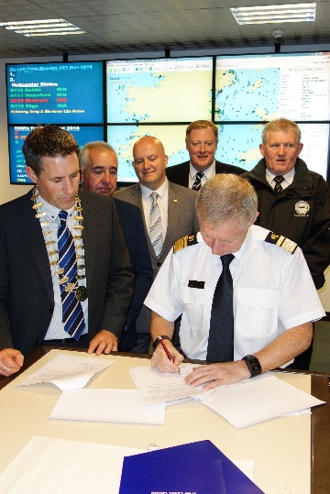

The Vincent O'Brien National Underwater Photography Competition

This underwater photography and videography competition was set up in memory of diver, Vincent O’Brien. The Limerick dive show will see the presentation of awards and prizes to the winners and runners up in each category. Its aim is to showcase the underwater world as seen through Irish eyes.
Beginners and Experienced users were catered for and people had a chance to enter their favourite images of 2017. Categories included wide angle, macro, foreign water, split shot and snorkel. There was also a dedicated category for video entries.
Huge thanks go to the people who entered, and to the sponsors for their generosity.

Image of Vincent Obrien on Dropbox:
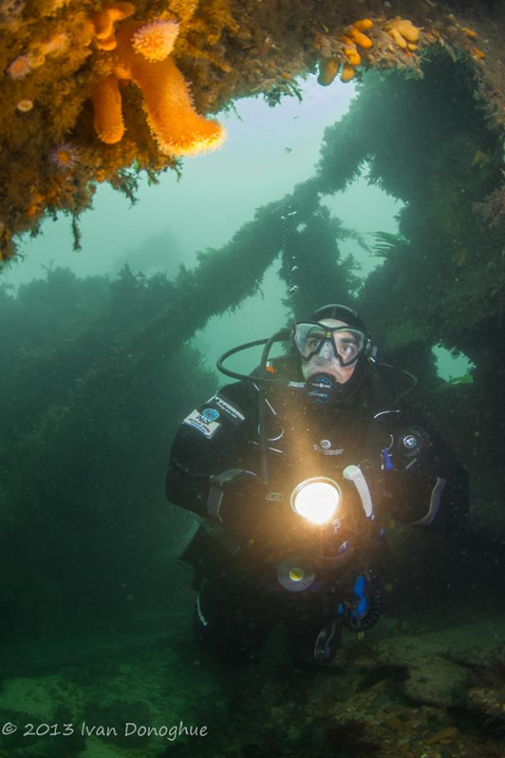

Image of Sponsors on Dropbox: https://www.dropbox.com/sh/r93r3yfnksgwzfb/AABQvtZkes2pwy9Q8ZqCdcoia?dl=0

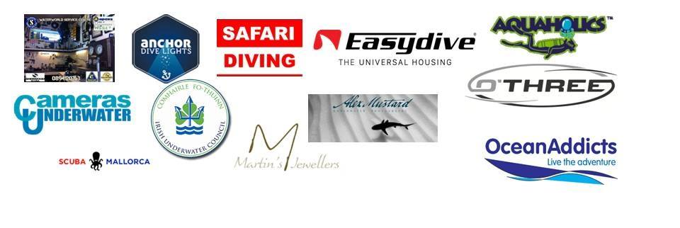

7th Annual CFT Underwater Photography Facebook Group Roadshow

Announcing the seventh Annual CFT Underwater Photographers Facebook Exhibition for 2018. The exhibition will be launched at Dive Ireland and will again tour the country with your support. This year we hope to again accept 99 photographs from members of the CFT Underwater Photography Facebook group for the exhibition.

The exhibition has toured the following locations in previous years…
• Dive Ireland
• Wexford County Council
• Galway Library
• Spike Island, Cork
• Kilmore Quay Seafood Festival, Wexford
• Science Week, Sligo Institute of Technology,
• Dublin City University, launch of The Water Institute, research institute based in DCU
• DCU Library
• Dun Laoighre, Co Dublin, The Lexicon Library
• SE Dive Rally CFT

We want members/participants/exhibitors to take the exhibition to their own part of the country, to a local swimming pool, sports center, libraries, community center, Tourist Information Centers, local festival, just about any community based location or event you can get. The added bonus for you is that you can use it to recruit for your local club and to promote the CFT Underwater Photography Facebook Group. Dive centers are also welcome to host the exhibition; we welcome all opportunities to promote underwater photography and scuba diving for all.

For more information contact Brian.Stone@DCU.ie

International and Local Speakers on Marine based interest

Paul “Duxy” Duxfield – Take it Easy with Duxy
Duxy has been a regular figure on the dive industry scene for the last 15yrs.
Upon returning from Egypt in the early noughties where he worked as a guide, he quickly established himself as the ‘go-to guy” for newbies to give the best advice upon starting out in underwater photography. Being sales manager at the two biggest UW photo retailers in the UK, he also found time to write for the popular diving press and has conducted over 50 underwater photo workshops here and around the world. Alongside his regular club and dive show appearances.

Endlessly patient and full of infectious enthusiasm he likes nothing more than helping people with their questions about underwater photography from what camera to buy, and then on how to use it and the necessary accessories to go with it. His mantra has always been ‘Best Advice’ even if that meant losing a sale occasionally, building up trust amongst the people he dealt with.

This year on the prompting of a couple of his trip regulars and stalwarts of the club and competition scene Phil and Anne Medcalf he joined with them to start up Blue Duck Photography drawing on all their skills so they could join forces and deliver the very best in sales and photo training. They’ve already had a very fast start and been delivering photo and digital editing advice to dive clubs around the country in a very short time”

Image: https://www.dropbox.com/home/Dive%20Show%20Team/Speakers/Duxy%20-%20Paul%20Duxfield

Nick Blake – Working with Natural Light
You only have to look at Nick’s website to see that he loves working with natural light – and has produced some stunning images using it. In this talk he will cover how light behaves under water, when shooting with natural light works, the techniques he uses and how he has made successful use of locations he has dived.

Nick started diving as a teenager in the 1980s but his longstanding interest in photography only moved underwater in 2004. That was with an Olympus compact camera, after which he moved on to Nikon DSLRs and currently shoots with a Nikon D810 full frame camera. He credits one to one tuition and encouragement from Martin Edge as being instrumental to his development and success.

His competition successes in recent years include the Grandmaster award in the UnderwaterPhotography.com international photo competition, winner of the Advanced British & Irish category in the BSoUP/Diver Print competition and British Underwater Photographer of the Year in the 2017 Underwater Photographer of the Year competition .

Image: https://www.dropbox.com/home/Dive%20Show%20Team/Speakers/Nick%20Blake

Ken O’Sullivan - ‘Ireland’s DEEP ATLANTIC’
Ken O’Sullivan has been a natural history filmmaker, cameraman and ocean conservationist for twelve years. He has produced, directed and shot natural history documentary series for RTÉ & TG4 and worked as freelance cameraman / director for BBC NHU, CBC Canada, ITV and cinematographer for TV commercials and drama projects.

Ken is currently shooting and presenting
‘Ireland’s DEEP ATLANTIC’ for RTÉ an ambitious natural history project exploring Ireland’s deep Atlantic waters for the first time in any TV production.
Ken also produced IFTA nominated, The Silver Branch, a creative, feature-length documentary for Irish Film Board on changing nature of our connection with landscape in Ireland, intended for a theatrical release.
Ken is a passionate marine conservationist and heavily involved in conservation projects on sharks, skates and rays, as well as cetacean research in Ireland, working closely with academic institutions, the Marine Institute and various conservation organisations.

Image: https://www.dropbox.com/home/Dive%20Show%20Team/Speakers/Ken%20OSullivan

Barry McGill - Exploration & Discovery in the North Atlantic – A Tale of Liners & Battleships
Barry McGill is a based deep wreck photographer and CCR instructor trainer with Indepth Technical. His main area of focus is exploration of deep water shipwrecks around the Irish coastline and he has been fortunate enough to discover and explore many significant virgin shipwrecks.

The presentation will contain many underwater images and film, including the use of 3D photogrammetry and will give an insight into the rewards and challenges of diving the iconic wrecks of the Lusitania and H.M.S. Audacious.

Image: https://www.dropbox.com/home/Dive%20Show%20Team/Speakers/Barry%20McGill

Cathal Mullane – Cave Diving the Burren
Cathal Mullane is a cave diver, caver and CFT club instructor based in Limerick. Trained by Martyn Farr and the late Artur Kozlowski, he has been active in the Clare and South Galway region for the last 10 years. Cathal’s presentation gives an insight into the types of caves beneath the Burren, exploration projects ongoing and the equipment needed underground and underwater.

Image: https://www.dropbox.com/home/Dive%20Show%20Team/Speakers/Cathal%20Mullane

Yvonne Lynch - A Rebreather Perspective
Yvonne learned to dive with Dalkey Scubadivers in 1995 and has been an active member of the club since then. An instructor now, she loves to help new divers discover the joy and wonders of diving. She took up rebreather diving in 2014. Last year, she became the first Irish woman to dive the Lusitania. She is looking forward to sharing her experiences of becoming a rebreather diver at Dive Ireland 2018.

Image: https://www.dropbox.com/home/Dive%20Show%20Team/Speakers/Yvonne%20Lynch

Stewart “Stewie” Andrews – Jutland, WWI’s Greatest Sea Battle
Stewie Andrews has been fortunate to dive many deep wrecks around Europe, though his favourite dives are still the war losses off Donegal, including the 'classics' such as the battleship HMS Audacious (64m) and the ocean liner HMS Justicia (70m). Stewie has been involved in many virgin wreck dives including a very deep dive on RMS Empress of Britain (163m). Stewie's talk covers the history and exploration of the Jutland wrecks off Denmark, from the greatest sea battle of WWI, which involved 250 vessels and the loss of over 8,500 brave men. The expedition was sponsored by CMAS and UNESCO.

Stewie Andrews has been fortunate to dive deep wrecks off Ireland, the English Channel, Denmark, Greece and Norway. Diving for 30 years and rebreather diving for 14 years, his favourite dives are still the war losses off Donegal, including the 'classics' such as the super-dreadnought battleship HMS Audacious (64m). Stewie has been involved in many virgin dives on wrecks such as HMS Curacoa (125m), HMS Carinthia (115m), RMS Amazon (117m), SS Flavia (105m), HMS Viknor (86m), as well as some very deep dives such as SS Assyria (140m) and RMS Empress of Britain (163m). He has been involved in several TV documentaries and has been on both sides of the video camera. In 2014, he took up the challenge of deep wreck photography. Stewie's talk covers the history and exploration of the Jutland wrecks off Denmark, from the greatest sea battle of WWI.

Image: https://www.dropbox.com/home/Dive%20Show%20Team/Speakers/Stewart%20Andrews

Paraic Slattery – Rescue 118
Paraic is previous member of Aughinish Diving Club. He learned to fly helicopters in 2007 and after a number of years flying to Oil Rigs in the North Sea, he is now a pilot based in Sligo working for the Irish Coast Guard Helicopter, Rescue 118. The Rescue Helicopter is a Sikorsky S92A. Paraic’s talk will give a general overview of Helicopter Search & Rescue in Ireland and interaction with the diving community.

Image: https://www.dropbox.com/home/Dive%20Show%20Team/Speakers/Paraic

Pertti Arvonen - Underwater navigation with the new technology, UWIS
Pertti Arvonen is CEO of UWIS Oy from Finland. He has 20 years experiences in global industry, mainly from power electronic sector. He is co-founder of UWIS Oy which was established at summer 2014 for only one purpose – to create the new navigation and communication system for divers.

Image: https://www.dropbox.com/home/Dive%20Show%20Team/Speakers/Pertti%20Arvonen

Rory & Tony O’Callaghan – Seasearch
Rory O'Callaghan is the National Coordinator for the National Marine Monitoring Scheme (Adopt a Site). An initiative that began in 2017 encouraging clubs to record biodiversity at their local sites, to date over 3,000 species records have been submitted to the National Biodiversity Data Centre thanks to this scheme

Tony O’Callaghan is Seasearch Coordinator for Ireland since 2012 and a Seasearch Observer tutor since 2013. The Seasearch Coordinator in Ireland reports to the overall UK Seasearch coordinator & the CFT Scientific Officer.

Seasearch Ireland will be running a program of talks and discussions on various aspects of marine conservation and practical uses of citizen science in the marine environment. This will include talks on kelp monitoring in Galway Bay, using drones to study marine sites, seal behaviour and much, much more. We'll also be hosting a discussion panel on the value of citizen science and the various citizen science projects in the marine environment that divers can become involved in. Following on from our successes in expanding the Adopt a Site scheme in 2017 we'll be providing updates on it, Seasearch activities in 2017 and looking forward to 2018. In addition to all the talks we're looking forward to saying "Hi" to all our recorders and hoping to welcome a few more to the Seasearch project in 2018.

Images: https://www.dropbox.com/home/Dive%20Show%20Team/Speakers/Seasearch

Simon Berrow – The Shannon Estuary Dolphin
Simon Berrow is Chief Science Officer and Acting CEO of the IWDG. He is a founder member of the IWDG and has been co-ordinating its activities since his return to Ireland in 2000. He is Project Manager of the Shannon Dolphin and Wildlife Foundation ( www.shannondolphins.ie ) based in Kilrush, Co. Clare.

Although the Shannon dolphins have been studied since 1993, still relatively little is known about their ecology and behaviour. We still do not really know how many dolphins use the Shannon estuary, wether the numbers are increasing or stable or the social structure of the dolphins.

Image: https://www.dropbox.com/home/Dive%20Show%20Team/Speakers/Simon%20Berrow%20-%20IWDG

Tom Doyle - An introduction to jellyfish – ambassadors of the marine environment
Dr Tom Doyle is a marine biologist with expertise in jellyfish and animal biotelemetry (satellite tracking). He is internationally recognised in the field of gelatinous zooplankton (jellyfish), with particular expertise on the socio-economic impacts of jellyfish (development of treatment for jellyfish stings, negative interactions with salmon aquaculture) and mapping the broadscale distribution and abundance of key gelatinous groups. He has deployed satellite tags, data loggers and acoustic tracking devices on various marine species (inc. sea bass, blue sharks, leatherback sea turtles and even jellyfish) to determine animal movements, migration patterns and behaviour. Tom also carries out research on marine litter and microplastics (sources of marine litter, ingestion and food web transfer of microplastics). Tom is currently a lecturer in Zoology at NUI Galway but in April 2018 he will be moving to the School of Biological, Earth and Environmental Sciences, at University College Cork.

Image: https://www.dropbox.com/home/Dive%20Show%20Team/Speakers/Tom%20Doyle

- Extensive Trade show and exhibitions
- The Irish Underwater Council Instructors, Diving and Training Officers Conference
- The Irish Underwater Council Annual General Meeting

